

Use Case Specification: Supervisor eCL Submission
For
eCoaching Log

Change History Log

Date | Version | Description | Author
08/05/2014 | 1.0 | Initial Document | Doug Stearns
08/08/2014 | 1.1 | Updates from review | Doug Stearns
09/09/2014 | 1.2 | Updates from additional review and phase 2 development | Doug Stearns
10/10/2014 | 1.3 | P13479 – eCL Warning Log for CSR  Still more additional requirements | Doug Stearns
10/31/2014 | 1.5 | P13659 – eCL ETS Data Feed  Added ETS sub-reasons to 3.9 and ETS as source to 3.12 | Doug Stearns
11/04/2014 | 1.6 | P13753 – eCL Access for Sr Exec Mgmt  7.1 Sr. Managers - added WPWL51 | Doug Stearns
11/13/2014 | 1.7 | P13659 – eCL ETS Data Feed  Removed ETS UI changes from 3.9 and 3.12 | Doug Stearns
11/24/2014 | 1.8 | P13542 – eCL Warnings for Supervisors  Inserted 3.7 (subsequent entries renumbered and updated accordingly)  Updated 3.9  Added 4.4  Updated Figure 1 | Doug Stearns
02/17/2015 | 1.9 | P14323 – eCL No self coaching logs  Updated 3.4 so that submitters can’t submit logs to themselves | Doug Stearns
02/18/2015 | 1.10 | P14304 – eCL Warning Reasons Dashboard (No Duplicates)  Added 4.5 Duplicate Warnings  Updated Figure 1 | Doug Stearns
02/19/2015 | 1.11 | P14323 – eCL No self coaching logs  Modified 3.4 | Doug Stearns
05/27/2015 | 1.12 | P15029 – eCL AHT for Supervisor Module  Modified 3.10 to add additional AHT sub-reasons | Doug Stearns
06/08/2015 | 1.13 | P15008 – eCL New job codes for Supervisor module  Added two job codes to 7.1 | Doug Stearns
09/01/2015 | 1.14 | TFS604 – eCL New AHT sub-reason for Supervisor module  Modified 3.11 to add new sub-coaching | Doug Stearns
09/02/2015 | 1.15 | TFS667 – eCL WPOP70 submit all modules  Updated 7.1 – added WPOP70 to others | Doug Stearns
10/20/2015 | 1.16 | CR 841 eCL Open up Supervisor Module to job code WACQ13 – Updated 7.1 – Added WACQ13 to others | Lisa Stein

Table of Contents

1. Brief Description 6
2. Participating Actors 6
2.1 Primary 6
2.2 Secondary 6
3. Basic Flow of Events 7
3.1 Identify coachable event. 7
3.2 Access eCoaching Log website submission page. 7
3.3 Select Supervisor module. 7
3.4 Select the appropriate Supervisor (required selection) 7
3.5 Select the appropriate program (required selection) 7
3.6 Select the coaching delivery option (required selection). Select Yes to deliver coaching. 7
3.7 Select if Progressive Disciplinary Warning (required selection). Select No for not a warning. 7
3.8 Enter or select the date of coaching (required selection) 7
3.9 Select if Customer Service Escalation (required selection; default to No). 7
3.10 Select applicable coaching reasons, whether opportunity or reinforcement, and applicable sub-coaching reasons (required selection) 8
3.11 Enter details of the behavior to be coached (required entry; free form text up to 3000 characters) 9
3.12 Enter details from the coaching session including action plans developed (required entry; free form text up to 3000 characters). Note: Yes selected in 3.6 (not available if No selected). 9
3.13 Select how the coaching opportunity was identified (required selection) 9
3.14 Select if there is a Call Record associated with this coaching (required selection; default to No) 9
3.15 Select to verify that all information on the form is true and complete (required selection) 10
3.16 Submit the Supervisor eCoaching Log 10
4. Alternative Flows 11
4.1 Select the coaching delivery option. [Step 3.6] 11
4.2 Select if Customer Service Escalation. [Step 3.9] 11
4.3 Select if Call Record is associated with this coaching. [Step 3.14] 11
4.4 Select if Progressive Disciplinary Warning. [Step 3.9] 12
4.5 Duplicate Warning. [Step 3.16] 12
5. Preconditions 13
5.1 eCoaching Log website available. 13
5.2 eCoaching Log database available. 13
5.3 eCoaching Log database populated with correct and current hierarchy information for Supervisors, Managers, Senior Managers. 13
6. Postconditions 13
6.1 eCoaching Log submitted. 13
6.2 eMail notifications sent appropriately. 13
7. Assumptions and Dependencies 13
7.1 Access to Supervisor module will be limited to those with the following job codes. 13
8. Business Rules 13
8.1 none 13
9. Technical Requirements 13
9.1 none 13
10. Activity Diagrams 14

Table of Figures
Figure 1 – Supervisor eCL Submission 12

Brief Description
Allow eCoaching Logs for call center Supervisors.

Participating Actors

Primary

Supervisors

Managers

Secondary

Senior Managers

Basic Flow of Events

Identify coachable event.

Access eCoaching Log website submission page.

Select Supervisor module.

Select the appropriate Supervisor (required selection)

Supervisors displayed for selection will be those with job codes of WACS40. Submitters of logs will not be available for selection from the list of Supervisors.

Select the appropriate program (required selection)

Possible programs are:
Marketplace
Medicare
NA

Select the coaching delivery option (required selection). Select Yes to deliver coaching.

Possible options are:
Yes, I will be delivering the coaching session
No, I will not be delivering the coaching session

Select if Progressive Disciplinary Warning (required selection). Select No for not a warning.

Note: this question is only available if the submitter is the Employee’s immediate supervisor or manager as defined in the Employee Hierarchy and coaching is Direct (Yes, I will be delivering the coaching session).

Possible options are:
Yes
No

Enter or select the date of coaching (required selection)

Select if Customer Service Escalation (required selection; default to No).

Possible options are:
Yes
No

Note: this question is only available if the Progressive Disciplinary Warning is No.

Select applicable coaching reasons, whether opportunity or reinforcement, and applicable sub-coaching reasons (required selection)

Possible options are:
Coaching Reason | Opportunity and Reinforcement
- Sub-Coaching Reason
AHT | Opportunity and Reinforcement
- Appropriate use of hold
- Keeping the call on task
- Navigational efficiency
- Non transfer opportunity
- Over servicing the caller
- Utilizing appropriate scripting
- Other: Specify reason under coaching details.
Attendance | Opportunity and Reinforcement
- Other: Specify reason under coaching details.
CCO Processes and Procedures | Opportunity and Reinforcement
- CCO Learning
- CUP
- Desk to Desk
- Security and Privacy Incident
- Other: Specify reason under coaching details.
Coaching | Opportunity and Reinforcement
- Quality eCL Coaching
- Supervisor eCL Coaching
- Other: Specify reason under coaching details.
Corporate and Program Compliance | Opportunity and Reinforcement
- Annual Review
- CoR
- eRes
- IPC
- ISO
- Mandatory Training
- Secure Floor Policy
- Other: Specify reason under coaching details.
ETS | Opportunity and Reinforcement
- Other: Specify reason under coaching details.
KUDOS | Reinforcement
- Other: Specify reason under coaching details.
Professional Development | Opportunity and Reinforcement
- Business Acumen
- Critical Thinking
- IDP
- Leadership Skills
- Other: Specify reason under coaching details.
Quality Performance | Opportunity and Reinforcement
- Customer Satisfaction
- PPoM
- Verint
- Other: Specify reason under coaching details.
Reports Catalogue | Opportunity and Reinforcement
- Incorrect Escalation: ARC
- Incorrect Escalation: DMEPOS
- Incorrect Escalation: EE / MM
- Incorrect Escalation: RME
- Incorrect Transfers
- ISG Usage
- OMR: Default Qualifier
- OMR: Short Calls Inbound
- OMR: Short Calls Outbound
- OMR: Cancelled Calls
- OMR: Open Calls
- Other: Specify reason under coaching details.
Schedule Adherence | Opportunity and Reinforcement
- Other: Specify reason under coaching details.

Enter details of the behavior to be coached (required entry; free form text up to 3000 characters)

Enter details from the coaching session including action plans developed (required entry; free form text up to 3000 characters). Note: Yes selected in 3.6 (not available if No selected).

Select how the coaching opportunity was identified (required selection)

Possible options are:
CSR Reported Issue
DMEPOS Escalations
Internal CCO Reporting
Training and Development
Walk By

Select if there is a Call Record associated with this coaching (required selection; default to No)

Possible options are:
Yes
No

Select to verify that all information on the form is true and complete (required selection)

Submit the Supervisor eCoaching Log

Alternative Flows

Select the coaching delivery option. [Step 3.6]

Select No to not deliver coaching session.

Continue with steps 3.7 through 3.11 above, skip 3.12.

Continue with Step 3.13 above

Select if Customer Service Escalation. [Step 3.9]

Select Yes is a Customer Service Escalation

Coaching Reason of Customer Service Escalation is automatically selected and disabled.

Select applicable Sub-coaching Reasons

Possible options are:
Coaching Reason | Opportunity and Reinforcement
- Sub-Coaching Reason
Customer Service Escalation | Opportunity
- Argues
- Blind transfers call
- Encourages / commits fraud
- Intentionally disconnects caller
- Threatens caller / employee
- Uses derogatory / disrespectful words
- Uses Profanity of any kind
- Verbally abusive
- Yells, Screams
- Other: Specify reason under coaching details.

Continue with Step 3.11 above.

Select if Call Record is associated with this coaching. [Step 3.14]

Select Yes call record is available.

Select the applicable call record source

Possible options are:
Verint
NGD ID
Avoke
UCID

Enter the appropriate valid identifier value for selected option

Continue with Step 3.15 above

Select if Progressive Disciplinary Warning. [Step 3.9]

Select Yes is a Progressive Disciplinary Warning

Select applicable coaching reason, opportunity, and applicable sub-coaching reasons (required selection). Note: only one Coaching Reason may be selected.

Possible options are:
Coaching Reason | Opportunity and Reinforcement
- Sub-Coaching Reason
Verbal Warning | Opportunity
- Attendance
- Conduct (including Call Avoidance)
- ETS
- Quality/Performance
- Security or Privacy Issue
- Other Policy (non-Security/Privacy)
Written Warning | Opportunity
- Attendance
- Conduct (including Call Avoidance)
- ETS
- Quality/Performance
- Security or Privacy Issue
- Other Policy (non-Security/Privacy)
Final Written Warning | Opportunity
- Attendance
- Conduct (including Call Avoidance)
- ETS
- Quality/Performance
- Security or Privacy Issue
- Other Policy (non-Security/Privacy)

Continue with Step 3.16 above (note: details of behavior, coaching session, how identified, call record, and verification are not available for Warnings).

Duplicate Warning. [Step 3.16]

Warning for same Employee ID and with same Warning Given Date, Warning Reason, Sub-warning Reason, which is also Active and has a Status of Completed, will generate an error message of “A warning with the same category and type already exists. Please review your warning section in the My Dashboard for details.” The Warning is not submitted.

Preconditions

eCoaching Log website available.

eCoaching Log database available.

eCoaching Log database populated with correct and current hierarchy information for Supervisors, Managers, Senior Managers.

Postconditions

eCoaching Log submitted.

eMail notifications sent appropriately.

Assumptions and Dependencies

Access to Supervisor module will be limited to those with the following job codes.
Supervisors | WACS40, WFFA40, WISY13, WMPR40, WPPM11, WPPT40, WPSM11, WPSM12, WPSM13, WPSM14, WPSM15, WTTI02. WTTR12, WTTR40, WPOP11, WPPM12, WACQ13
Managers | WACS50, WBCO50, WFFA50, WMPR50, WPOP50, WPPM50, WPPT50, WTTR50
Sr. Managers | WACS60, WBCO70, WEEX90, WEEX91, WPOP60, WPPM60, WPPM70, WPPM80, WPPT60, WPWL51
Others | WPOP70

Business Rules

none

Technical Requirements

none

Activity Diagrams
Below is the activity diagram for the use case that provides a visual depiction of the flow of events.

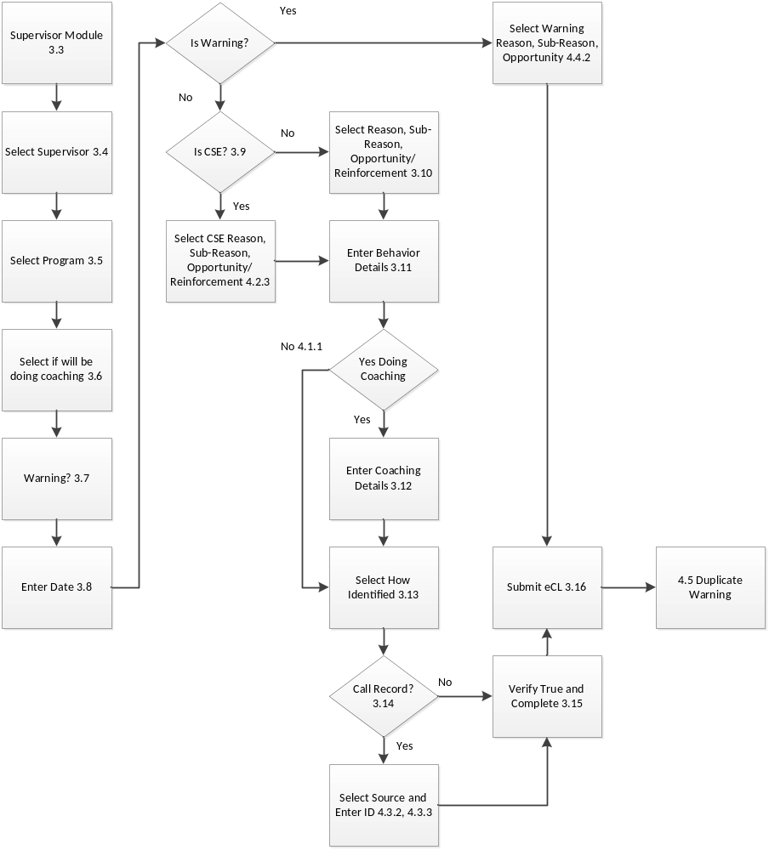
Figure 1 – Supervisor eCL Submission

